1.Git Setup <https://confluence.atlassian.com/bitbucket/set-up-git-744723531.html>

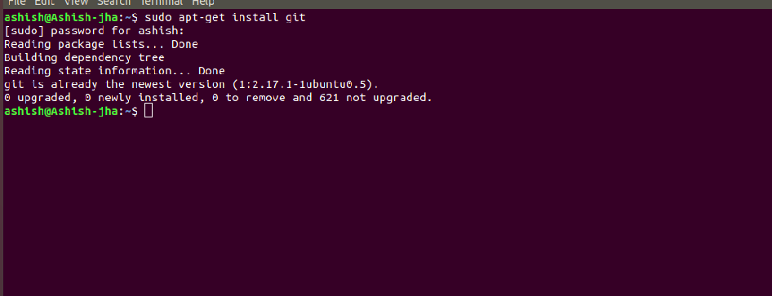

2.Initialize a Git Repository

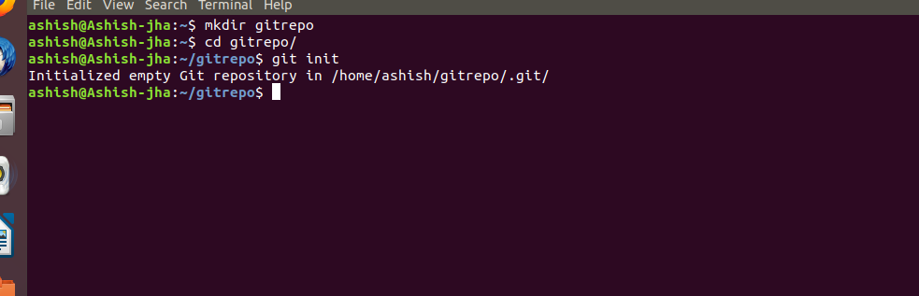

3.Add files to the repository

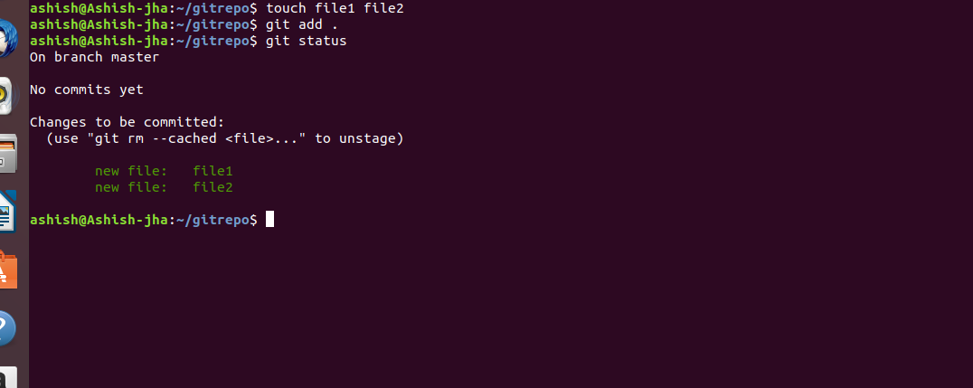

4.Unstage 1 file

ANS:

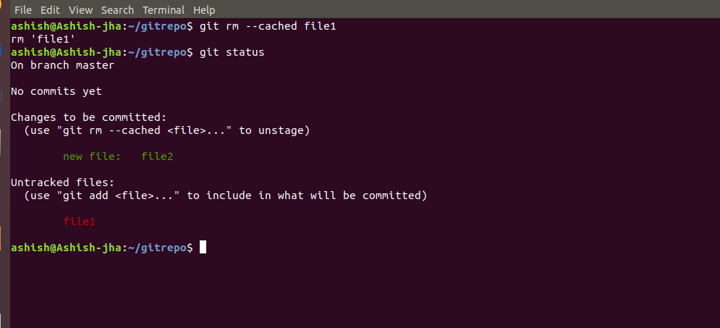

5.Commit the file

ANS:

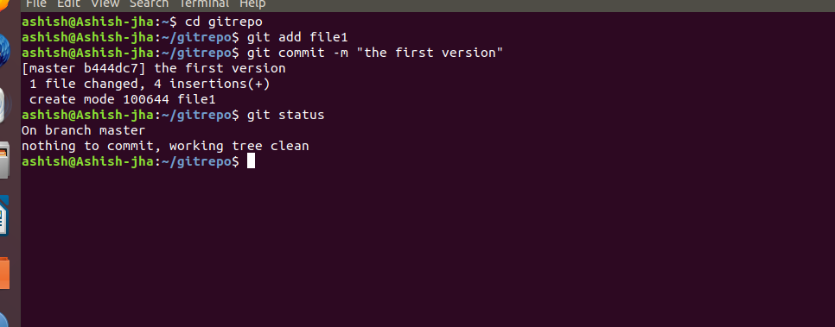

6.Add a remote

ANS:

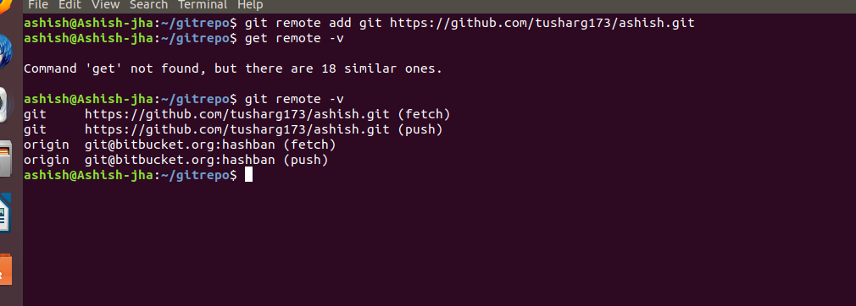

7.Undo changes to a particular file

Ans:

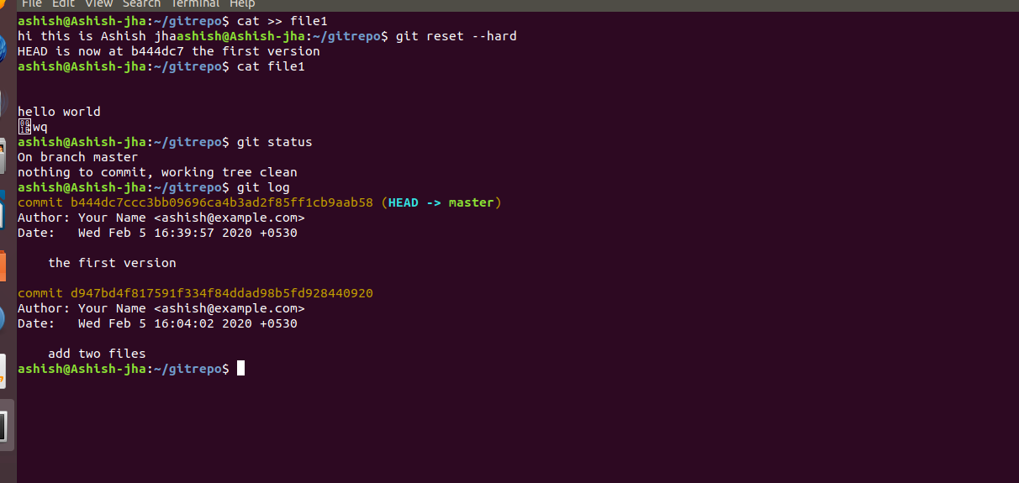

8.Push changes to Github

ANS:

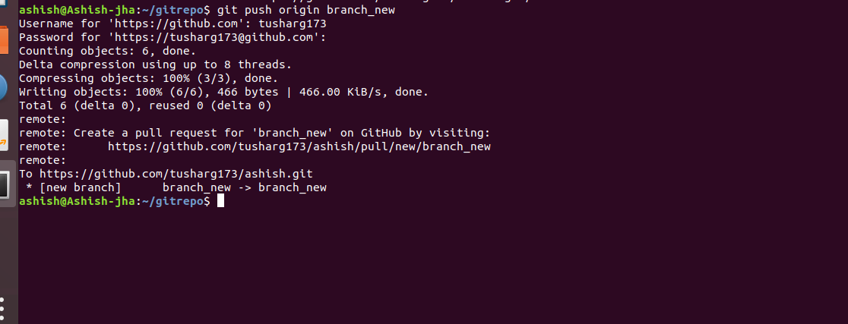

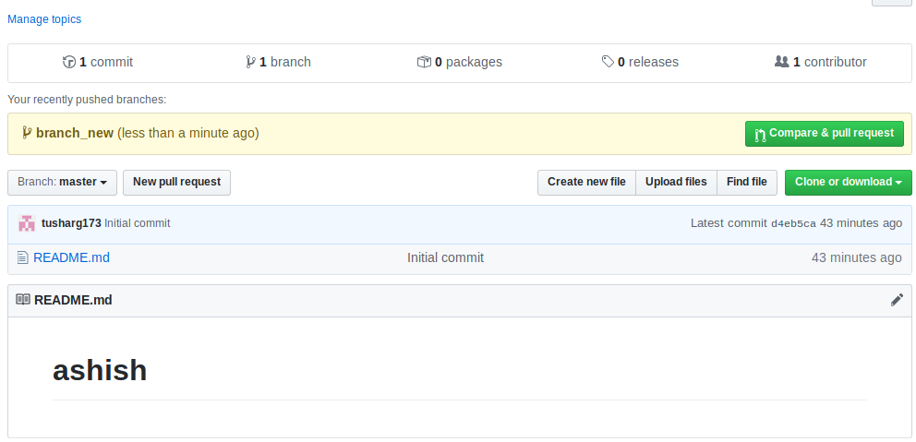

9.Clone the repository

ANS:

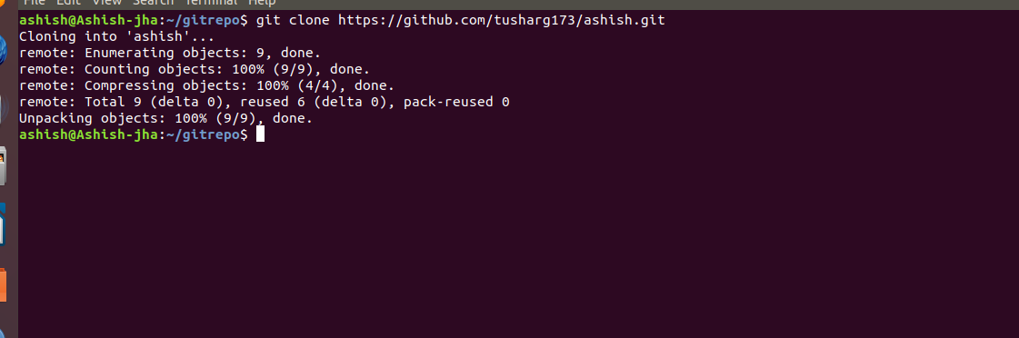

10. Add changes to one of the copies and pull the changes in the other.

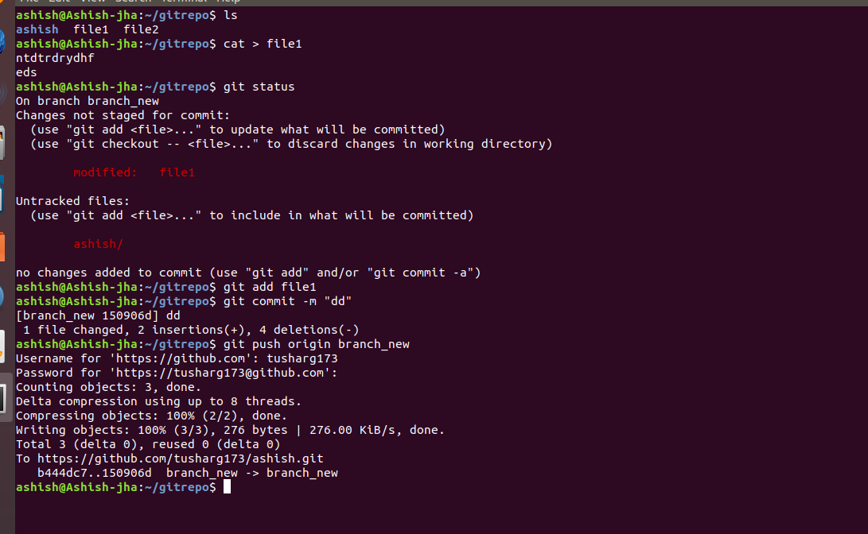

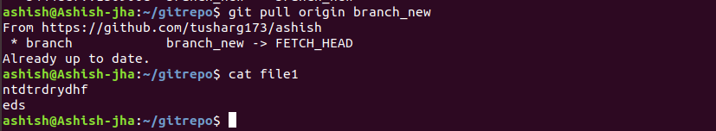

11.Check differences between a file and its staged version

ANS:

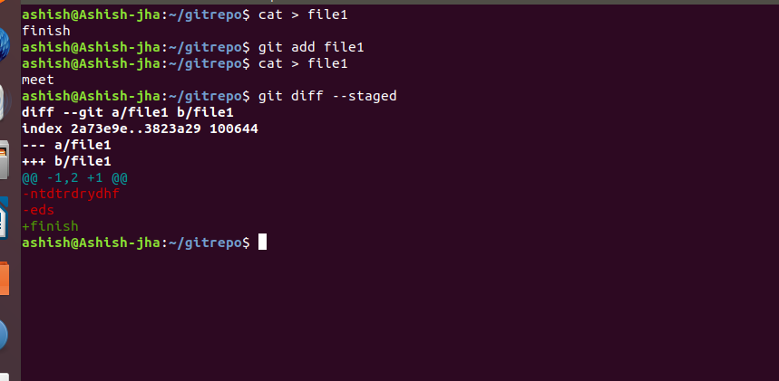

12.Ignore a few files to be checked in

ANS:

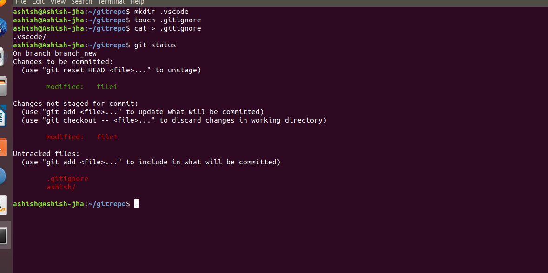

13.Create a new branch.

ANS:

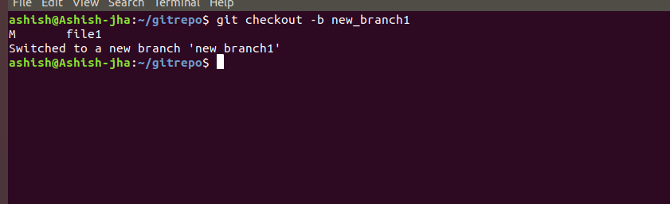

14.Diverge them with commits

1

ANS:

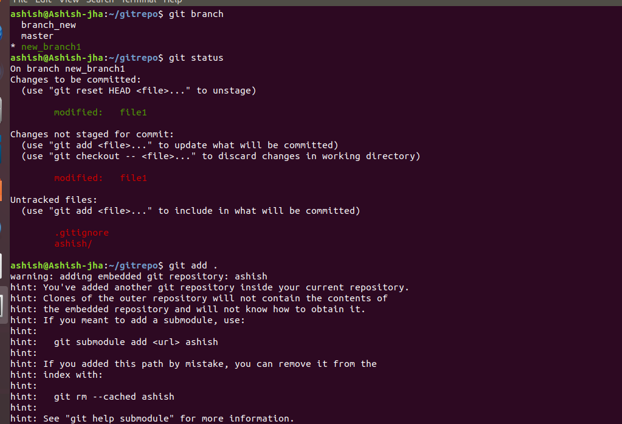

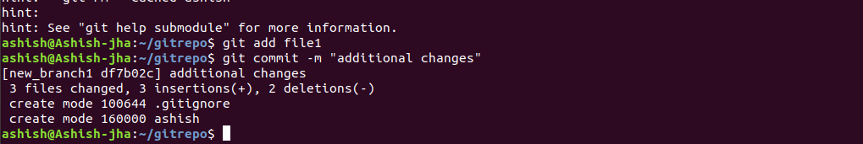

15. Edit the same file at the same line on both branches and commit

ANS:

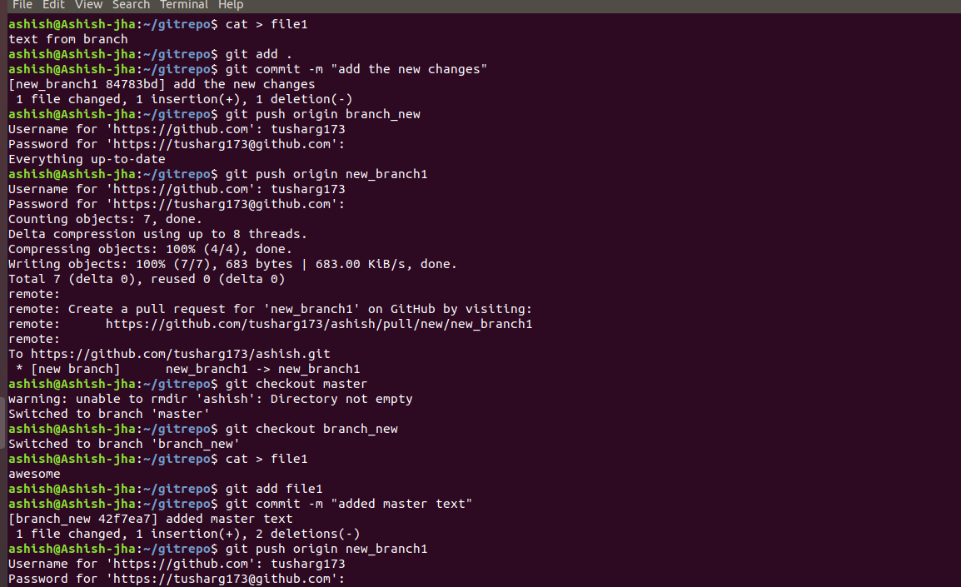

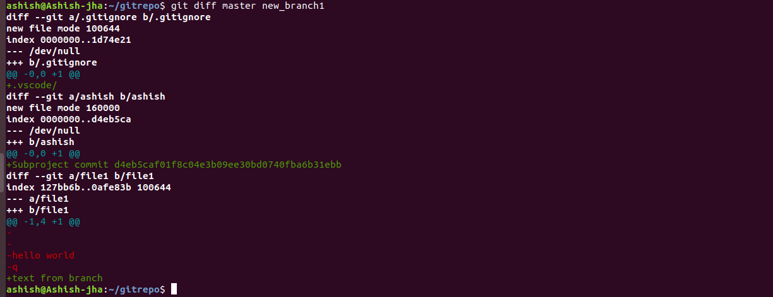

16.Try merging and resolve merge conflicts

ANS:

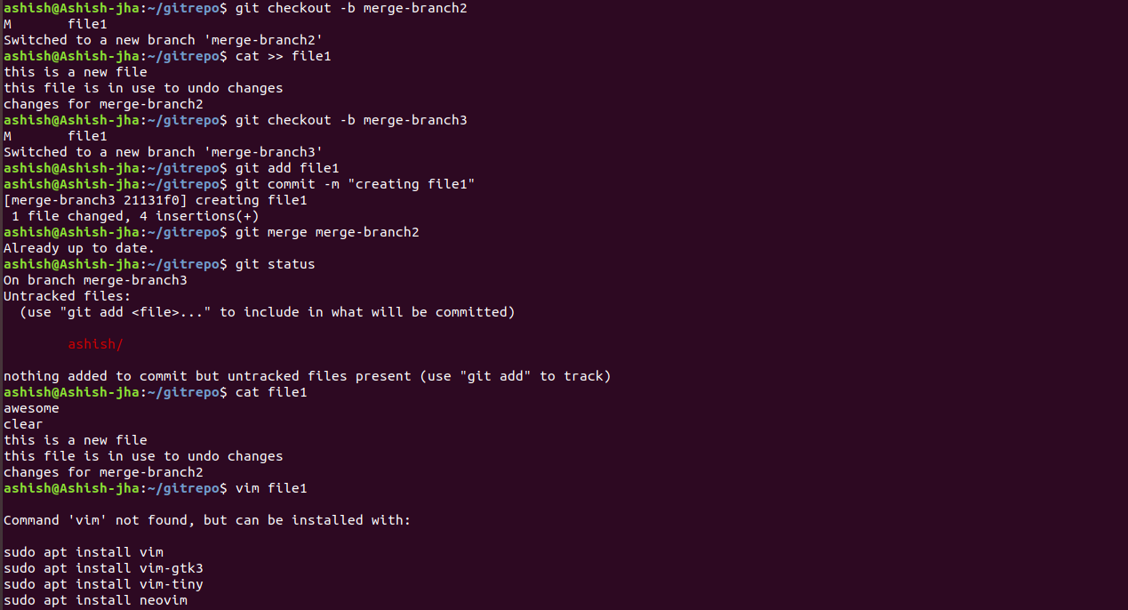

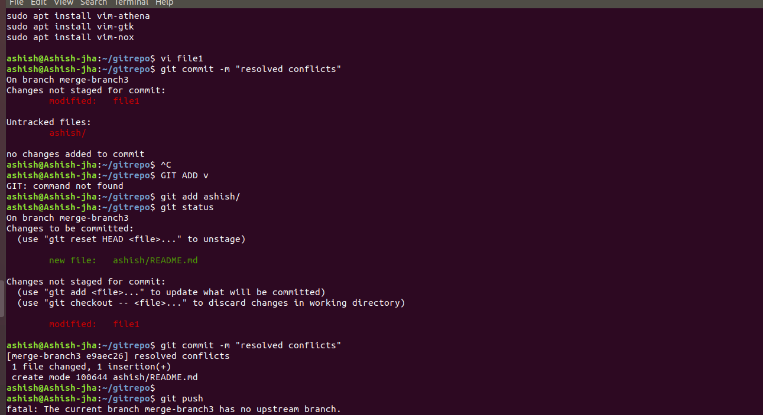

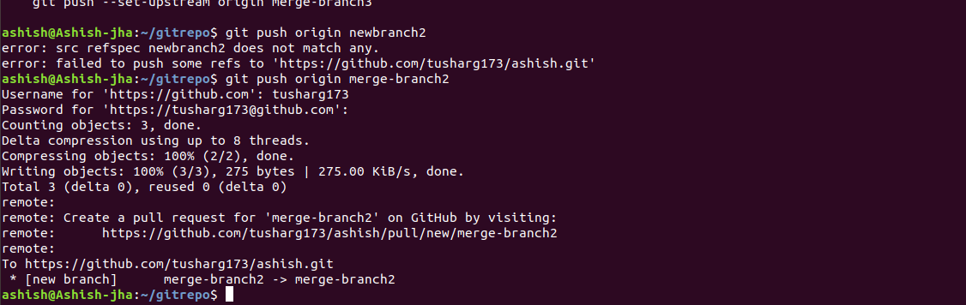

17. Stash the changes and pop them

ANS:

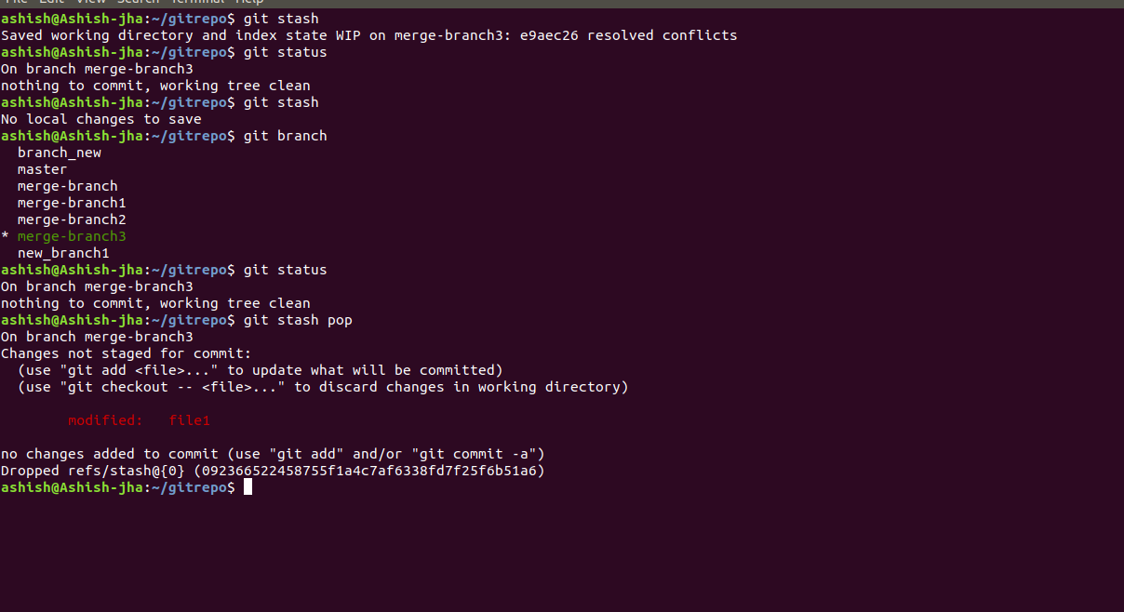

18.Stash the changes and pop them

Add the following code to your .bashrc file : color_prompt="yes"  
 parse_git_branch() {  
 git branch 2> /dev/null | sed -e '/^[^*]/d' -e 's/* \(.*\)/(\1)/'  
 }  
 if [ "$color_prompt" = yes ]; then  
 PS1='\u@\h\[\033[00m\]:\[\033[01;34m\]\W\[\033[01;31m\] $(parse_git_branch)\[\033[00m\]\$ '  
 else  
 PS1='\u@\h:\W $(parse_git_branch)\$ '  
 fi  
 unset color_prompt force_color_prompt

ANS:

After making file insert with ‘i’ and then pasted coded inside it and exit with ‘Esc’ from inserting mode and then save and quit

